**K4 CSF3133 REKA BENTUK ANTARA MUKA BERASASKAN WEB**

**SEM 3**

**LAB REPORT 1**

PREPARED FOR:

**ASSOC. PROF. TS. DR. WAN NURAL JWAHIR**

LAB ASSISTANT:

**MADAM WAN FATIN**

PREPARED BY:

**NUR ADLYNN SYAKIRAH BINTI NOR KHAIRUL ANUAR**

NO. MATRIC:

**S76245**

SUBMIT BY:

**22 OCTOBER 2025**

**1.4 Structure of an HTML Document**

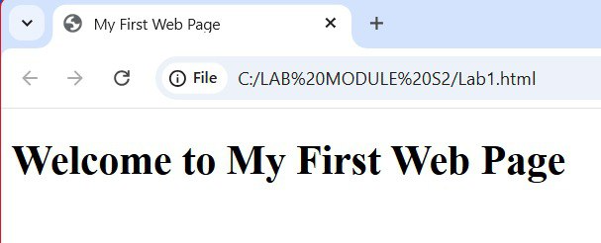

**1.5 Basic HTML Tags**

**1.5.1 Headings**

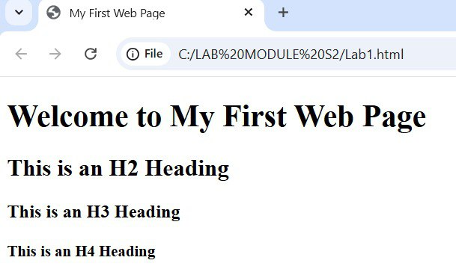

**1.5.2 Paragraphs and Text Formatting**

**1.5.3 List (Ordered and Unordered)**

**1.6 Links and Images**

**1.6.1 Add a Hyperlink**

**1.6.2 Insert a Image**

**1.6.3 Commenting in HTML**

**1.7 LAB EXERCISE**

**1.7.1 Designing Simple Personal Webpage**

